Integrating Cayenne on TTN

RM1xx Series

Application Note v1.0

# Intro duction

RM1xx modules can transmit data anywhere so that users can view it on website, mobile app and etc. This application note demonstrates that data sent by RM1xx travels to The Things Network (TTN) and is redirected to Cayenne MyDevice so that data is displayed in widget. (The test is done with RM191 and the setup for RM186 can be slightly different)

# Requirement

* DVK-RM816 or DVK-RM191 with the latest firmware
* [UwTerminalX](https://github.com/LairdCP/UwTerminalX) (v1.03 or later recommended)
* smartBASIC application (test.temp.thing.sb)
* LoRaWAN gateway (e.g. [Laird Sentrius RG1xx](https://www.lairdtech.com/products/rg1xx-lora-gateway))

# Overview

Cayenne is IoT data processing system that can display transmitted data in visualized form, for example, with icons and graph. A LoRaWAN server (e.g. TTN) can be set up so that it receives data from end-device and forwards that data to an external application server in the format it can understand. We captured the data such as temperature on DVK-RM191 and sent it over to Cayenne in the format it can understand.

# Test Setup

First, DVK needs to be set so that it can access to temperature sensor and Button1. To do so, put jumper on J7 pin 1-2 and J18 pin 2-3.

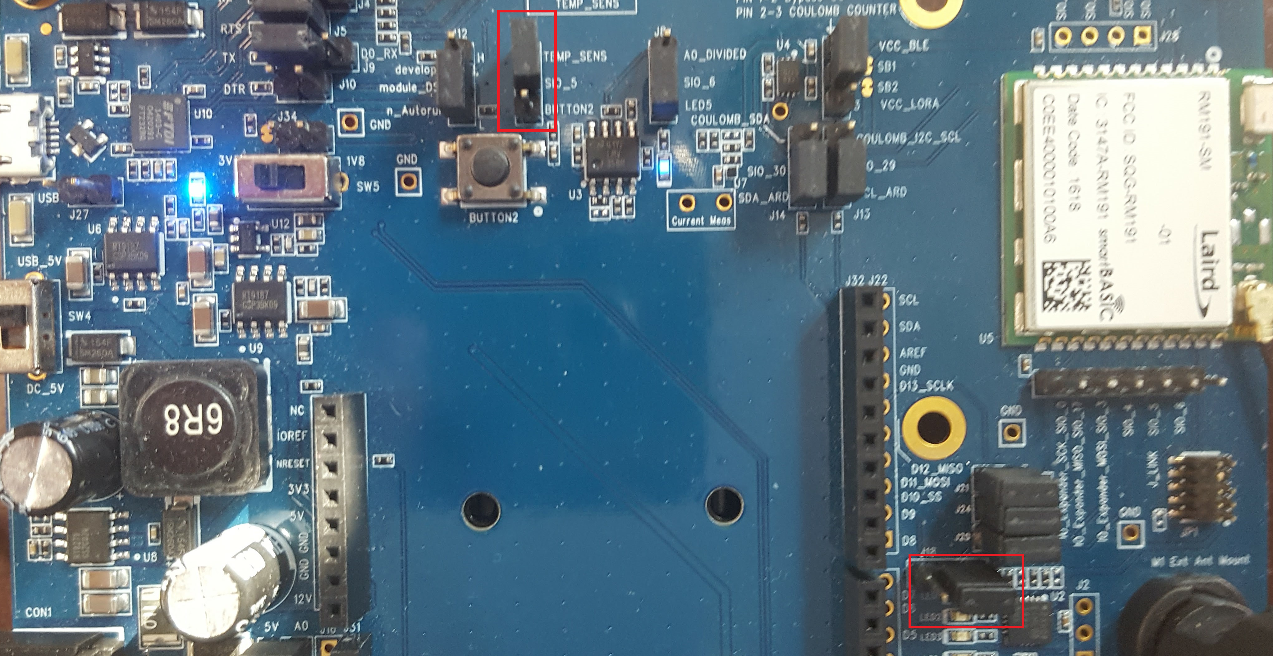

Figure 1 DVK-RM191 pin setup

Now, you can set up software pieces.

1. Register for an account on cayenne <https://cayenne.mydevices.com/cayenne/dashboard/start> and verify your account
2. Sign up for a TTN account and login on <https://console.thethingsnetwork.org/>
3. Set up your gateway, application, end-devices up to use TTN

* <https://www.thethingsnetwork.org/docs/gateways/registration.html>
* <https://www.thethingsnetwork.org/docs/applications/add.html>
* <https://www.thethingsnetwork.org/docs/devices/registration.html>

1. Add a new device on Cayenne. LoRa > The Things Network > Cayenne LPP, paste the dev EUI here and add it
2. On TTN, go back to the application >integrations tab, and then click add integration and select cayenne, the process ID you get from the Cayenne page URL after the /lora/ part of the URL (for example the highlighted in <https://cayenne.mydevices.com/cayenne/dashboard/lora/3e795080-xxxx-xxxx-xxxx-51a105d3afc2>
3. Go to the payload formats tab and change it to ‘Cayenne LPP’ from custom.

Now you should be able to configure the LoRa keys on the RM1xx, reset the module, then run the smartBASIC application. It will attempt to join the LoRa network. Once joined, you can issue the command “lora post” to send data from RM1xx to Cayenne.

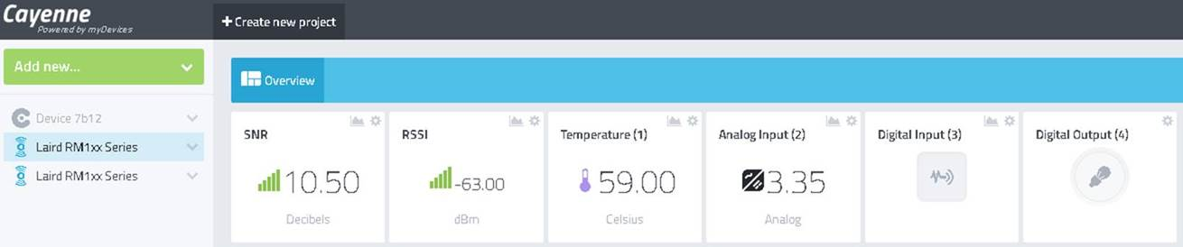

Figure 2 Displayed data on Cayenne

Note in Figure 2 that Analog Input(2) is voltage of the power supply/battery. Digital input (3) is Button1 on the DVK board and Digital Output (4) is the LED on the board.

# Resources

Cayenne Payload Structure - <https://mydevices.com/cayenne/docs/lora/#lora-cayenne-low-power-payload>

RM1xx Setup Guides – <http://www.lairdtech.com/products/rm1xx-lora-modules#documentation-tab>

# Revision History

|  |  |  |  |
| --- | --- | --- | --- |
| Version | Date | Notes | Approver |
| 1.0 | 27 Sept 2017 | Initial Release | Seokwoo Yoon |
|  |  |  |  |